ROAD ACCIDENT ANALYSIS

- Total Casualties
select sum(number_of_casualties) as Total_Casualties
from road_accident
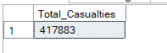
- CY Casualties
select sum(number_of_casualties) as CY_Casualties
from road_accident
where YEAR(accident_date)= '2022'
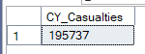

For Filter:
select sum(number_of_casualties) as CY_Casualties
from road_accident
where YEAR(accident_date)= '2022' and road_surface_conditions= 'Dry'
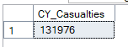
- CY Accident
select count(distinct accident_index ) as CY_Accident
from road_accident
where YEAR(accident_date)= '2022'
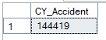
- Total Fatal Casualties
select sum(number_of_casualties) as Fatal_Casualties
from road_accident
where accident_severity= 'Fatal'
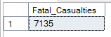
- Total Serious Casualties
select sum(number_of_casualties) as Serious_Casualties
from road_accident
where accident_severity= 'Serious'
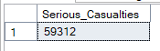

- Total Slight Casualties
select sum(number_of_casualties) as Slight_Casualties
from road_accident
where accident_severity= 'Slight'
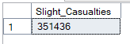
- Percentage of slight casualties
select cast(sum(number_of_casualties) as decimal(10,2))*100/
(select cast(sum(number_of_casualties) as decimal(10,2)) from road_accident)
as Percentage_Slight_Casualties
from road_accident
where accident_severity= 'Slight'
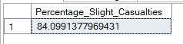

- CY Casualties By Vehicle type
select
case
when vehicle_type in ('Agricultural vehicle') then 'Agriculture'
when vehicle_type in ('Car','Taxi/Private hire car') then 'Car'
when vehicle_type in ('Motorcycle over 500cc','Motorcycle 50cc and under','Motorcycle over 125cc and up to 500cc','Motorcycle 125cc and under') then 'Bike'
when vehicle_type in ('Bus or coach (17 or more pass seats)','Minibus (8 - 16 passenger seats)') then 'Bus'
when vehicle_type in ('Goods 7.5 tonnes mgw and over','Goods over 3.5t. and under 7.5t','Van / Goods 3.5 tonnes mgw or under') then 'Van'
else 'Other'
End as vehicle_group,
sum(number_of_casualties) as CY_Casualties
from road_accident
where YEAR(accident_date)='2022'
Group by
case
when vehicle_type in ('Agricultural vehicle') then 'Agriculture'
when vehicle_type in ('Car','Taxi/Private hire car') then 'Car'
when vehicle_type in ('Motorcycle over 500cc','Motorcycle 50cc and under','Motorcycle over 125cc and up to 500cc','Motorcycle 125cc and under') then 'Bike'
when vehicle_type in ('Bus or coach (17 or more pass seats)','Minibus (8 - 16 passenger seats)') then 'Bus'
when vehicle_type in ('Goods 7.5 tonnes mgw and over','Goods over 3.5t. and under 7.5t','Van / Goods 3.5 tonnes mgw or under') then 'Van'
else 'Other'
End
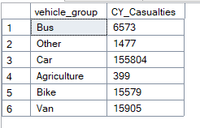

- CY_casualties by month trend
select DATENAME(month, accident_date) as Month_name, sum(number_of_casualties) as CY_Casualties
from road_accident
where YEAR(accident_date)='2022'
Group by DATENAME(month, accident_date)
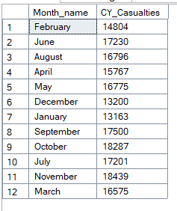
- Casualties by road type
select road_type, sum(number_of_casualties) as CY_casualties
from road_accident
where YEAR(accident_date)='2022'
Group by road_type
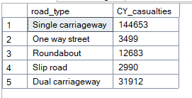
- Casualties by urban / rural area
select urban_or_rural_area, sum(number_of_casualties) as CY_casualties
from road_accident
where YEAR(accident_date)='2022'
Group by urban_or_rural_area
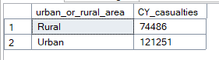

- Casualties by Light condition
select
case
when light_conditions in ('Daylight') then 'Day'
else 'Dark'
End as Light_group,
sum(number_of_casualties) as CY_Casualties
from road_accident
where YEAR(accident_date)='2022'
Group by
case
when light_conditions in ('Daylight') then 'Day'
else 'Dark'
End

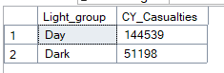
- Top 10 Casualities by Location
select Top 10 local_authority, sum(number_of_casualties) as Total_casualties
from road_accident
Group by local_authority
Order by Total_casualties desc
